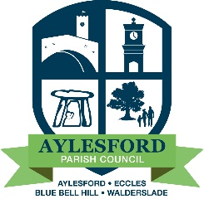
Aylesford Parish Council
23 Forstal Road, Aylesford, Kent, ME20 7AU
Tel: 01622 717084 Email: mel@aylesfordparishcouncil.org.uk
www.aylesfordparishcouncil.org.uk

Notice is hereby given of a meeting of the Planning Committee to be held on Tuesday 11th May 2023 at Aylesford Football Club Pavilion, Aylesford, commencing at the conclusion of the Annual Parish Meeting.

AGENDA

- Election of Chairman and Vice Chairman
  - Election of Chairman
b. Election of Vice Chairman

- Apologies

3. Declarations of Interests

4. Minutes of the last meeting held on 2nd May 2023

5. Planning Applications

5.1 TM/23/00403/FL - 79 Rochester Road Aylesford North

Proposed detached outbuilding and carport (retrospective)

Deferred from 2nd May meeting – For Discussion

5.2 TM/23/00836/FL - Click Aylesford Frank Sando Way, Aylesford South

Section 73 application to vary conditions 3 (plans list) and 22 (external lighting) of
planning permission TM/21/02866/FL (Construction of five buildings to provide six units
for industrial processes (Use Class E(g)(iii)); industrial (Use Class B2); and/or storage and
distribution (Use Class B8)) purposes, with ancillary offices and associated landscaping,
car parking, servicing and access arrangements)

Proposed comments – Condition Noted

5.3 TM/23/00850/FL – Court Farm Barn 90 High Street, Aylesford North

Insertion of 2 conservation Velux windows into the existing rear roof of the main barn

Proposed comments – No Objection

5.4 TM/23/00902/LDP – 204 Pratling Street, Aylesford North

Lawful Development Certificate Proposed: single storey rear and single storey side extensions

Proposed comments – No Objection

6. Any Other Correspondence

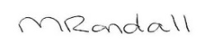

Melanie Randall
Clerk & Responsible Financial Officer Date 9th May 2023

